**National University of Computer and Emerging Sciences**



**Lab Exercise 07**

*for*

# Web Programming

# Spring 2024

**FAST School of Computer Science**

# LABORATORY OUTCOMES

The practical/exercises in this section are psychomotor domain Learning Outcomes (i.e. subcomponents of the COs), to be developed and assessed to lead to the attainment of the competency.

This Course is designed to take the students full adventure of “**Full Stack Web Development**.”

**Today’s Agenda**

Module 1: JQuery.

## Module 1: Playing with JQuery

* JQuery is a JavaScript Library.
* JQuery greatly simplifies JavaScript programming.
* JQuery is easy to learn.
* **JQuery Effects:**

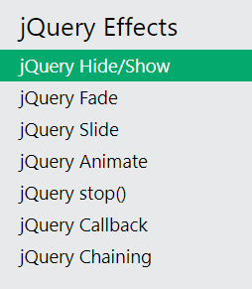

* **JQuery HTML:**

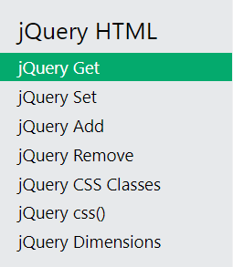

https://www.w3schools.com/jquery/default.asp

**You are done with your exercise(s), make your submission on Classroom.**

**BEST WISHES**

**References**

JQuery tutorial. (n.d.). Retrieved February 22, 2022, from <https://www.w3schools.com/jquery/default.asp>